Question Sheet for Engr Interviews

1. Hi my name is Zach and I heard you were the smartest person at uva do you have time to chat? – to randoms
2. I am doing customer discovery for my intro to engineering class and would like to hear your problems as a UVA student so my team can find solutions.
3. Can I record this conversation?
4. Tell me about your day and your frustrations you have with anything at UVA.
5. Do you have any problems with: food, housing, scheduling, employment, transportation, social, and hobbies?
6. Hardest part of your day?
7. Some unmet needs you have?
8. What product do you wish you had that does not exist yet?
9. What tasks take up most time in your day?
10. What could be done to improve UVA student experience?
11. What is the hardest part about being a UVA student?
12. What are your most important goals?
13. What are your biggest responsibilities?
14. Where do you like to study and why?
15. Do you find it hard to find available study spaces?
16. What are some ways that the process could be made easier?
17. Based on our conversation X is hard for you but Y is not, am I accurate
18. Is there anything else I should’ve asked?
19. Can I take a picture of us?

**This is the set of questions I asked them. I abbreviated the questions in my notes.**

**Name:** Justin Phillips **Email:** jbp9zt@virginia.edu Date: 11/13/19

**Notes:**

-Normal day: athlete, goes to practices, busses too late, goes to class

-**Product that doesn’t exist yet:** scooters cost too much, cheaper alternative

-ohill food

-closer library

**Goals:** Perform well and get a good education

**Hardest part of day:** Finding the will to late night study

**Most inconvenient thing about UVA athlete:** Busses don’t work early enough for athletes

**Take up most time in day:** Getting places, far to get to jpj

**Where do you study:** Study in dorm, hall, library

**What could make study process easier:** More seating, available space

**Photo:** 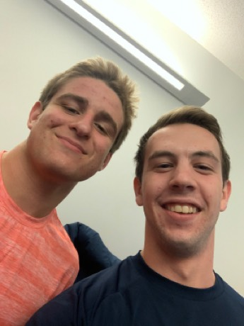

**Name:** Ray Costa **Email:** [rc3yw@virginia.edu Date: 11/13/19](mailto:rc3yw@virginia.edu)

**Notes:**

-Normal day: athlete, goes to practices, relax for hour, 3 hours of class, lifting, homework until late with intermediate periods to hangout in between

-**Product that doesn’t exist yet:** better way to get good food for student cost

-closer library

**Goals:** Have a good season and get good grades, transfer into e school

**Hardest part of day:** Finding good nutritional food for athletes, JPJ food only at dinner

**Most inconvenient thing about UVA athlete:** Mentoring and forced studying

**Take up most time in day:** Finding the will to do homework

**Where do you study:** Study in dorm, hall, library

**What could make study process easier:** Crowded and noisy, easier to find places to study, closer to first years, more libraries

**Photo:** 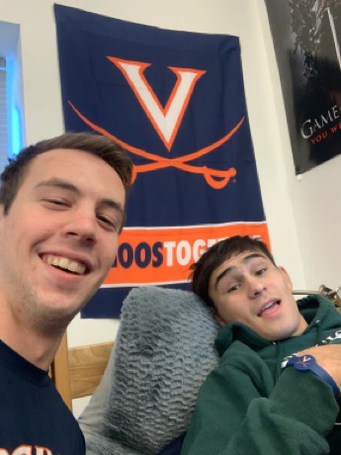

**Name:** Charlotte Kiss **Email:** cgk7uds@virginia.edu Date: 11/13/19

**Notes:**

-go to class, no breakfast too tired, class lunch class, nap or go study in library, dinner and do hw

-always sick, food sucks, study rooms in housing always full, water fountains, sis sucks, busses are earlier or late, wifi/cell service is inconsistent

-**hardest part:** can’t find a seat in newcomb

-take time: readings for classes

-goals: blueprint leadership, maintain good grades, job maybe

-fav study: clem 2, Shannon, starbucks

-hard to find study spaces: always something in clem 2

-made easier: prof told u how to study for the class

-nothing I should’ve asked

**Photo:** 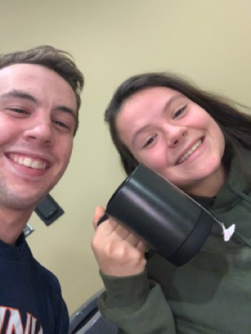

**Name:** Tenyeh Dixon **Email:** td6xq@virginia.edu Date: 11/17/19

**Notes:**

wake up early to lift, meetings and practice, go to class, get on them to do work, don’t understand that they’re tired, time management very important, no free time.

Food is always the same, transportation, if late it’s a big deal, tasks checked off

Hardest part: study hall time, tutoring

Unmet needs: better food options

Most time in day: tutoring/doing mandatory work

Study spot: JPJ

Hard to get spot: can be hard to find an open room

Made easier: waking up in morning

Should’ve asked: no

**Photo:** 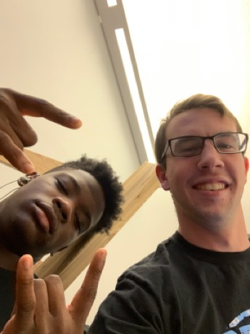

**Name:** Fentrell Cypress **Email:** fwc4p@virginia.edu Date: 11/17/19

**Notes:**

wake up early to lift, meetings and practice, go to class, get on them to do work, don’t understand that theyre tired, time management very important, no free time.

Food is always the same, transportation, if late it’s a big deal, tasks checked off

Hardest part: practice, harder than most stuff

Unmet needs: more food choices

Most time in day: study hall

Study spot: JPJ

Hard to get spot: can be hard to find an open room

Made easier: way to get places faster

Should’ve asked: no

**Photo:** 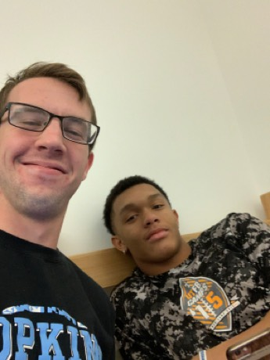

**Name:** Nick Hayeck **Email:** ngh6bax@virginia.edu Date: 11/17/19

**Notes:**

Day: wake up shower, einsteins,

Unmet needs: set an alarm based on rider app

Food sucks

Hardest part of day: grinding on homework

Study spot: dorm, alderman open place

Time in day: homework, chores

Goals: gpa up, stress less

Hard to find spot: harder in clark to find spot, peak hours

Should’ve asked: no

**Photo:** 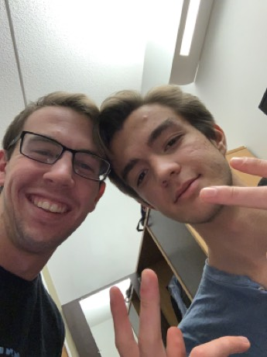

**Name:** Bryce Latina **Email:** bdl3rsf@virginia.edu Date: 11/17/19

**Notes:**

wake up, no breakfast, food after class, work, dinner at ohill close, go to gym, do homework

problems: constant construction, dining hall stops breakfast at 10/11, course scheduling sucks because some get horrible slots,

hardest part of day: time management

unmet needs: water fountains on each floor, cold water

hardest part of uva student: competitive academically and socially, prominent social life, hard to do both

takes up time in day: washing dishes here, by hand

study spot: quiet places, libraries, dorm

hard to find spaces: always available, but don’t know if want to go there, hard in dorm

could be made easier: request a spot, let people know to study

should’ve asked: no, best question asker ever

**Photo:** 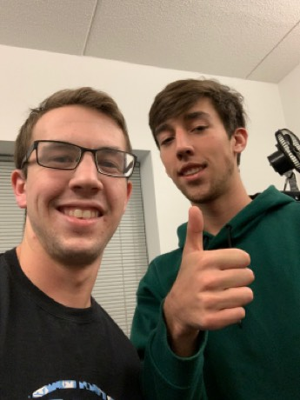

**Name:** Private Joe Reinkober **Email:** jpr8th@virginia.edu Date: 11/17/19

**Notes:**

Wake up, go to class, then gym, do homework, go to more class, nap, homework, dinner, hw and chill

Problems: coordination between professors, work on one day, hard then easy weeks, hard for time management

Hardest part of day: waking up in morning, motivated

Products wish you had: app that forces you to do core, track macros automatically

Time that could be cut down: naps

Goals: reach 175 lbs, 12% body fat

Study spot: dorm

Should’ve asked: no

**Photo:** 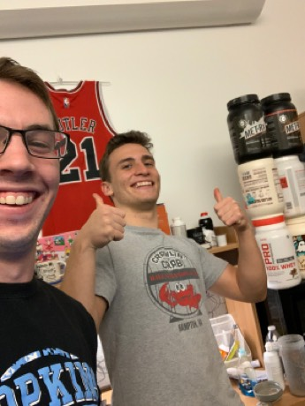

**Name:** Noal Zyglowicz **Email:**ntz3sw@virginia.edu Date: 11/17/19

**Notes:**

day: 9-2 class, lunch, office hours, free time, hw,

problems: engr: stress STS too much, not every major has specific work room, spend money on repairing stuff and monuments that could be more on student life

unmet needs: new equipment, study spaces

hardest part of day: meeting hw deadlines

product wish you had: better transportation, fast walkways like in airports

goals: graduate and get a job to support fam

study spot: NI lounge to get help, alone in physics library, dorm, alderman

hard to find space: at peak hours

ways to make easier: spend budget on study space

anything else asked: no

**Photo:** 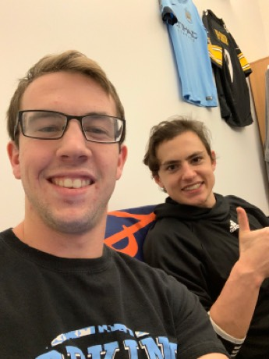

**Name:** Patrick Vook **Email:**pjv3rx@virginia.edu Date: 11/17/19

**Notes:**

Day: wake up, class, dining hall, class, library, come home

Problems: far walk, bathroom smells

Hardest part of day: waking up, finding what to do between classes

Takes up time in day: eating

Improve uva experience: self segregation

Goals: make money, learn something new, grow up

Study spot: clem, dorm, classrooms

Hard to find: no, find new spaces

Should’ve asked: no

**Photo:** 